System Requirements Specification Index

For

Home Page Testing - Selenium+Java

**Version 1.0**

**YAKSHA**

**Home Page Testing**

**System Requirements Specification**

# Project Abstract

**Home Page Testing is a use case to test the Home Page of Yaksha web portal using Selenium + Java.**

Home Page URL: https://www.yaksha.com/

**Following are the requirement specifications**:

|  |  |
| --- | --- |
|  | Home Page Testing |
| Check Title | Need to check if Home Page has Title: “Home-Yaksha” |
| Check Text | Need to check if Home Page has Text: “Request a Demo” |
| Check Link Exists | Need to check if Home Page has a Link for: “Explore Solutions” |
| Check Link is working | Need to check if Home Page has Link working and redirecting to correct place. Link To be tested is: “Explore Solutions” |

**Template methods for above testing are available in UITest.java class**

1. Once you open/import the project in your IDE, you can start working on it. Once done with development, **it is mandatory to run the test case before final submission**
2. Also make sure before final submission you commit all changes to git. For that open the project folder available on desktop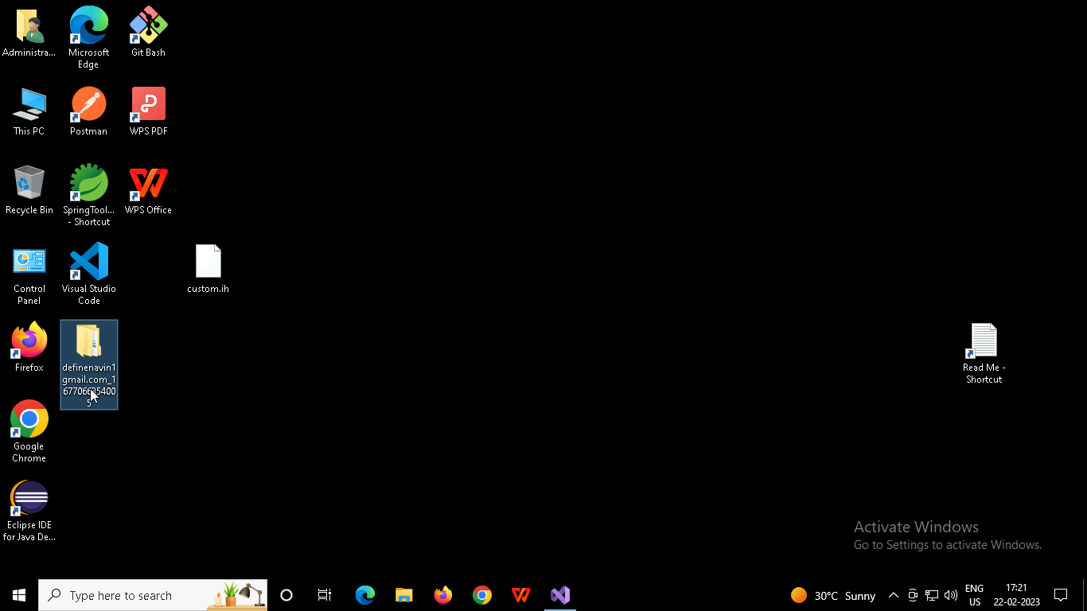
3. Right click in folder and open Git Bash

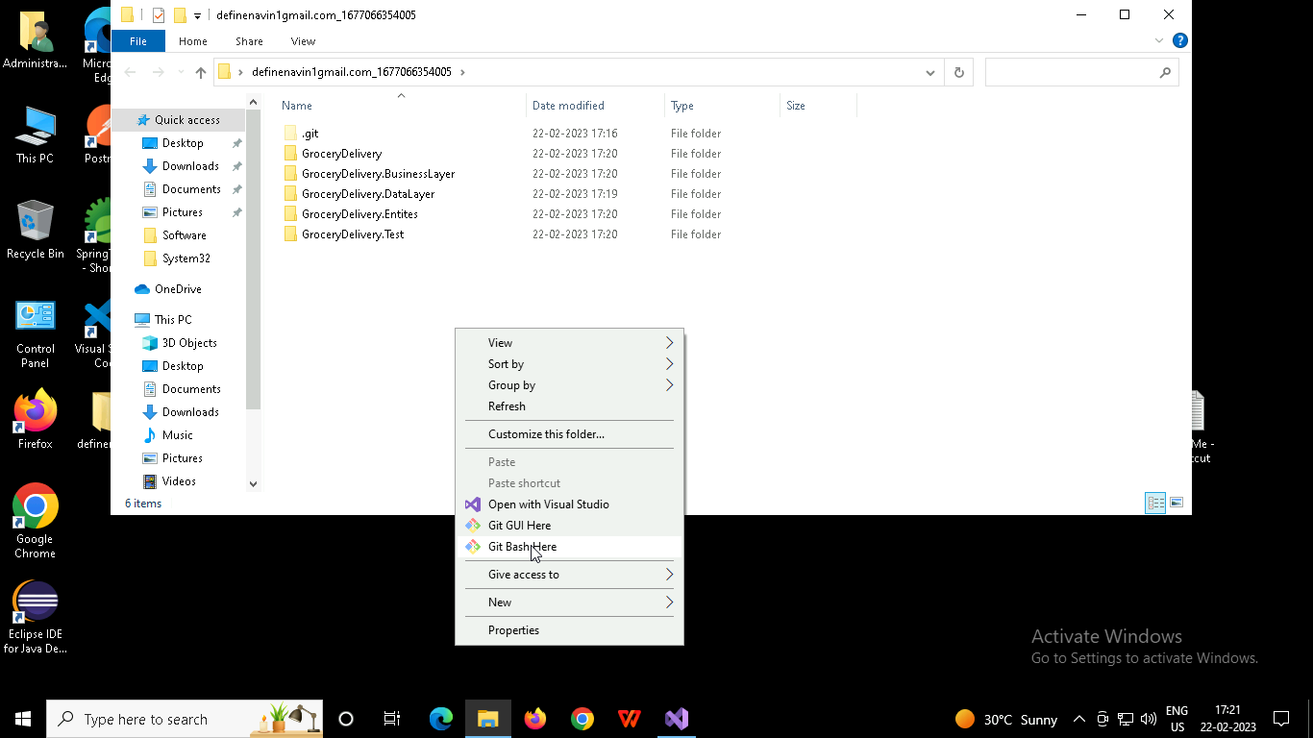

1. In Git bash terminal, run following commands
   1. git status
   2. git add .
   3. git commit -m “First commit”

(You can provide any message every time you commit)

* 1. git push

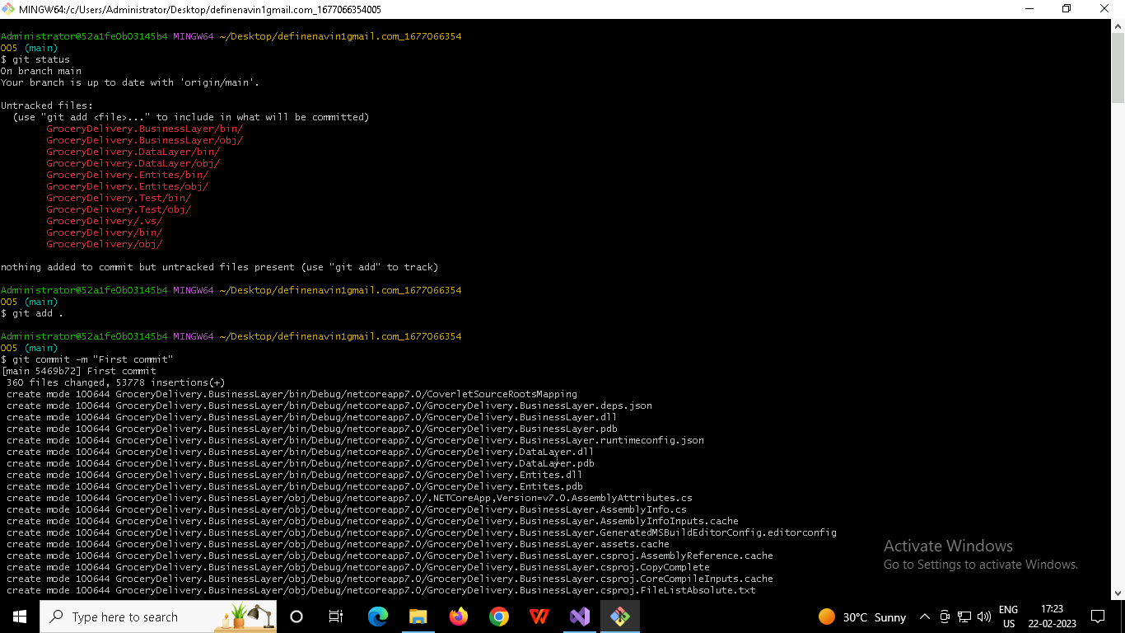

1. Once you are ready to do the final submission, click on Submit assessment after moving out of Full Screen mode

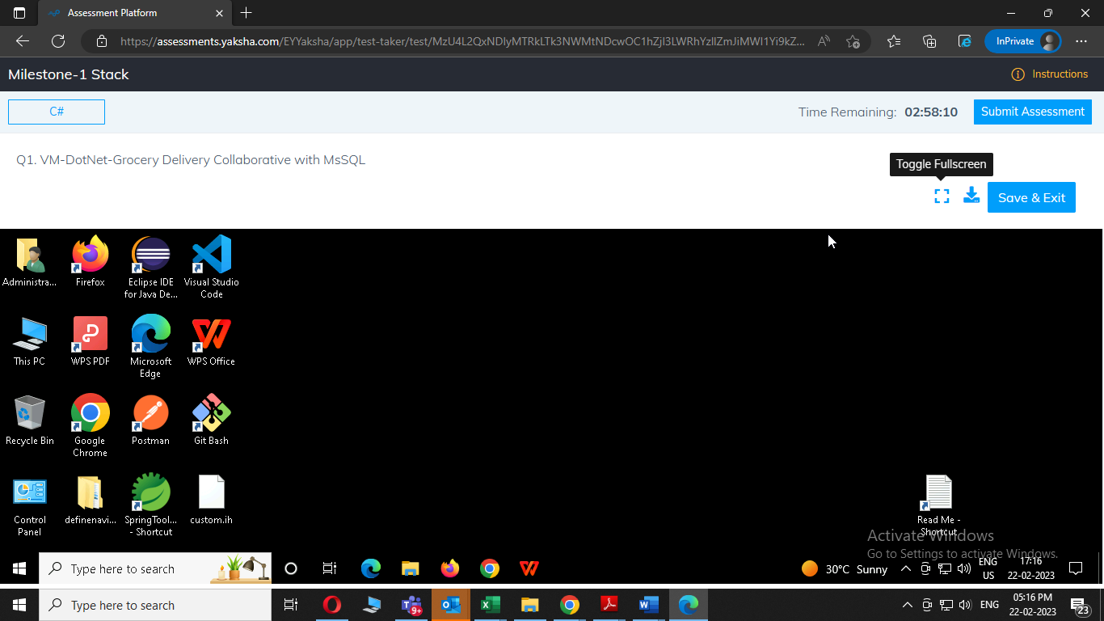

1. All credentials needed for any DB connections are available on desktop in Readme file